**Guides to Run the Katalon Studio**

1. Clone Project from GitHub
2. Open Katalon Studio
3. Login to your Katalon Studio Account

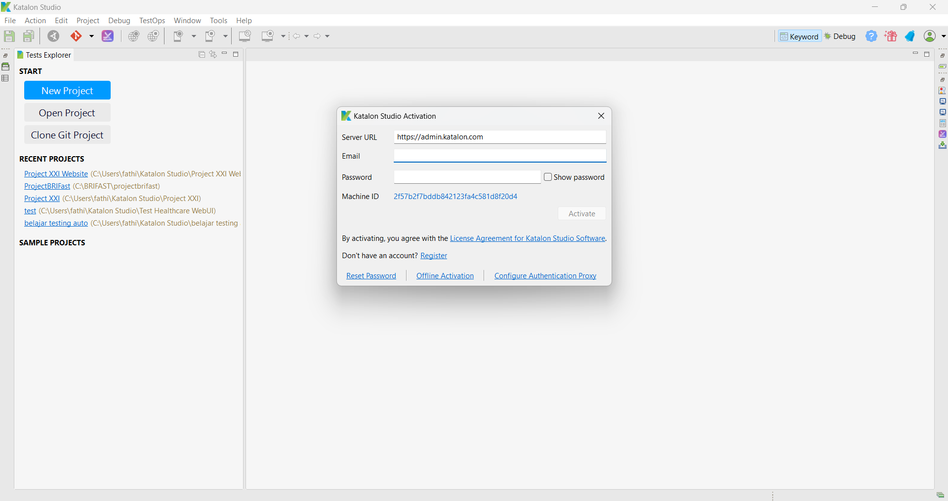

1. Open Project

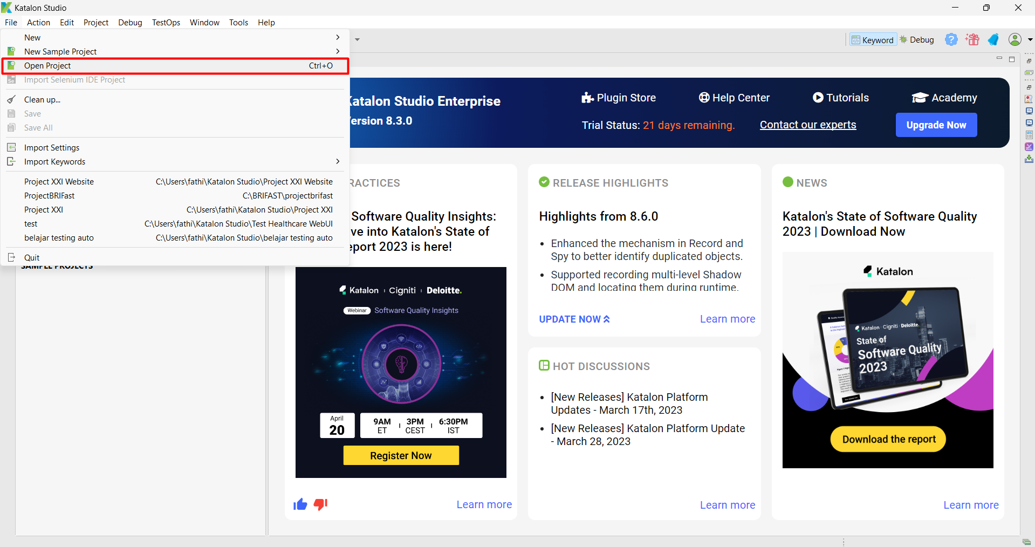

1. Choose the project that you clone before
2. Open Test Suites
3. And open the “Task XXI”

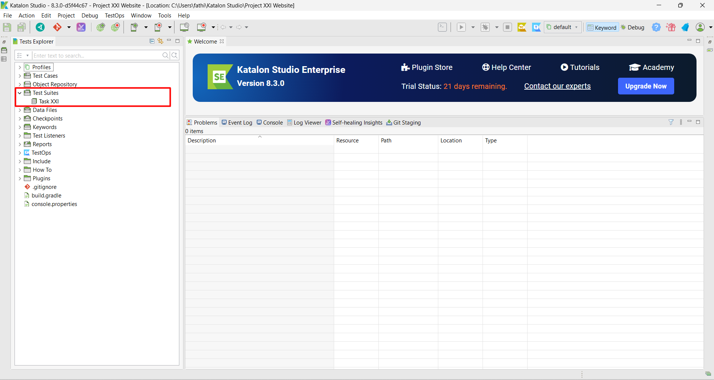

1. You will see the test suites which contain the scenarios to run

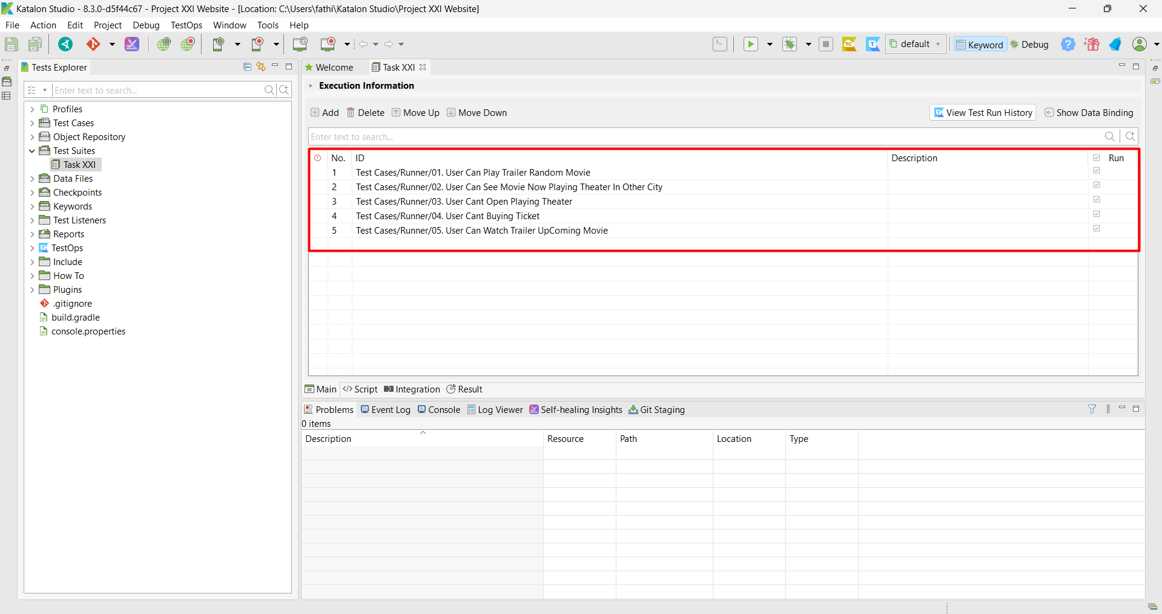

1. Now You can Run the Test Suites

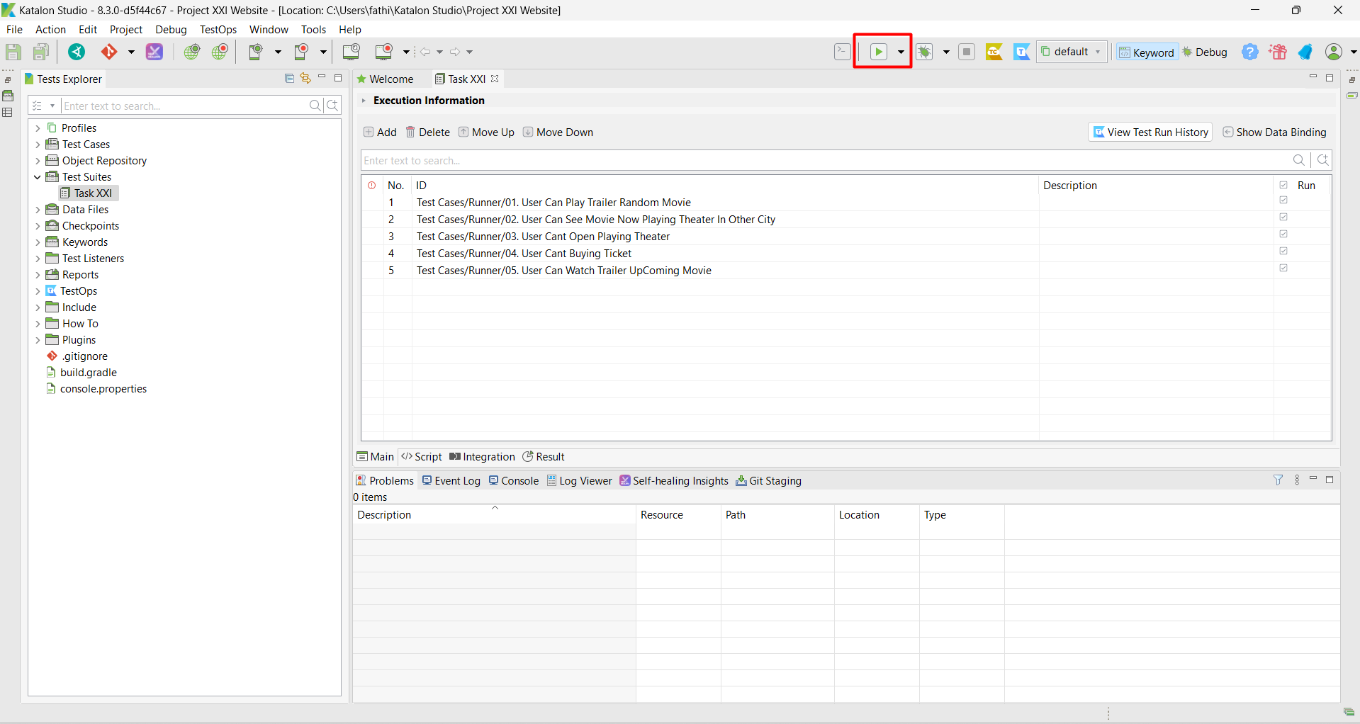

1. You Will see the Script Run, and you can see script log run and wait until test suites done (green bar will be full)

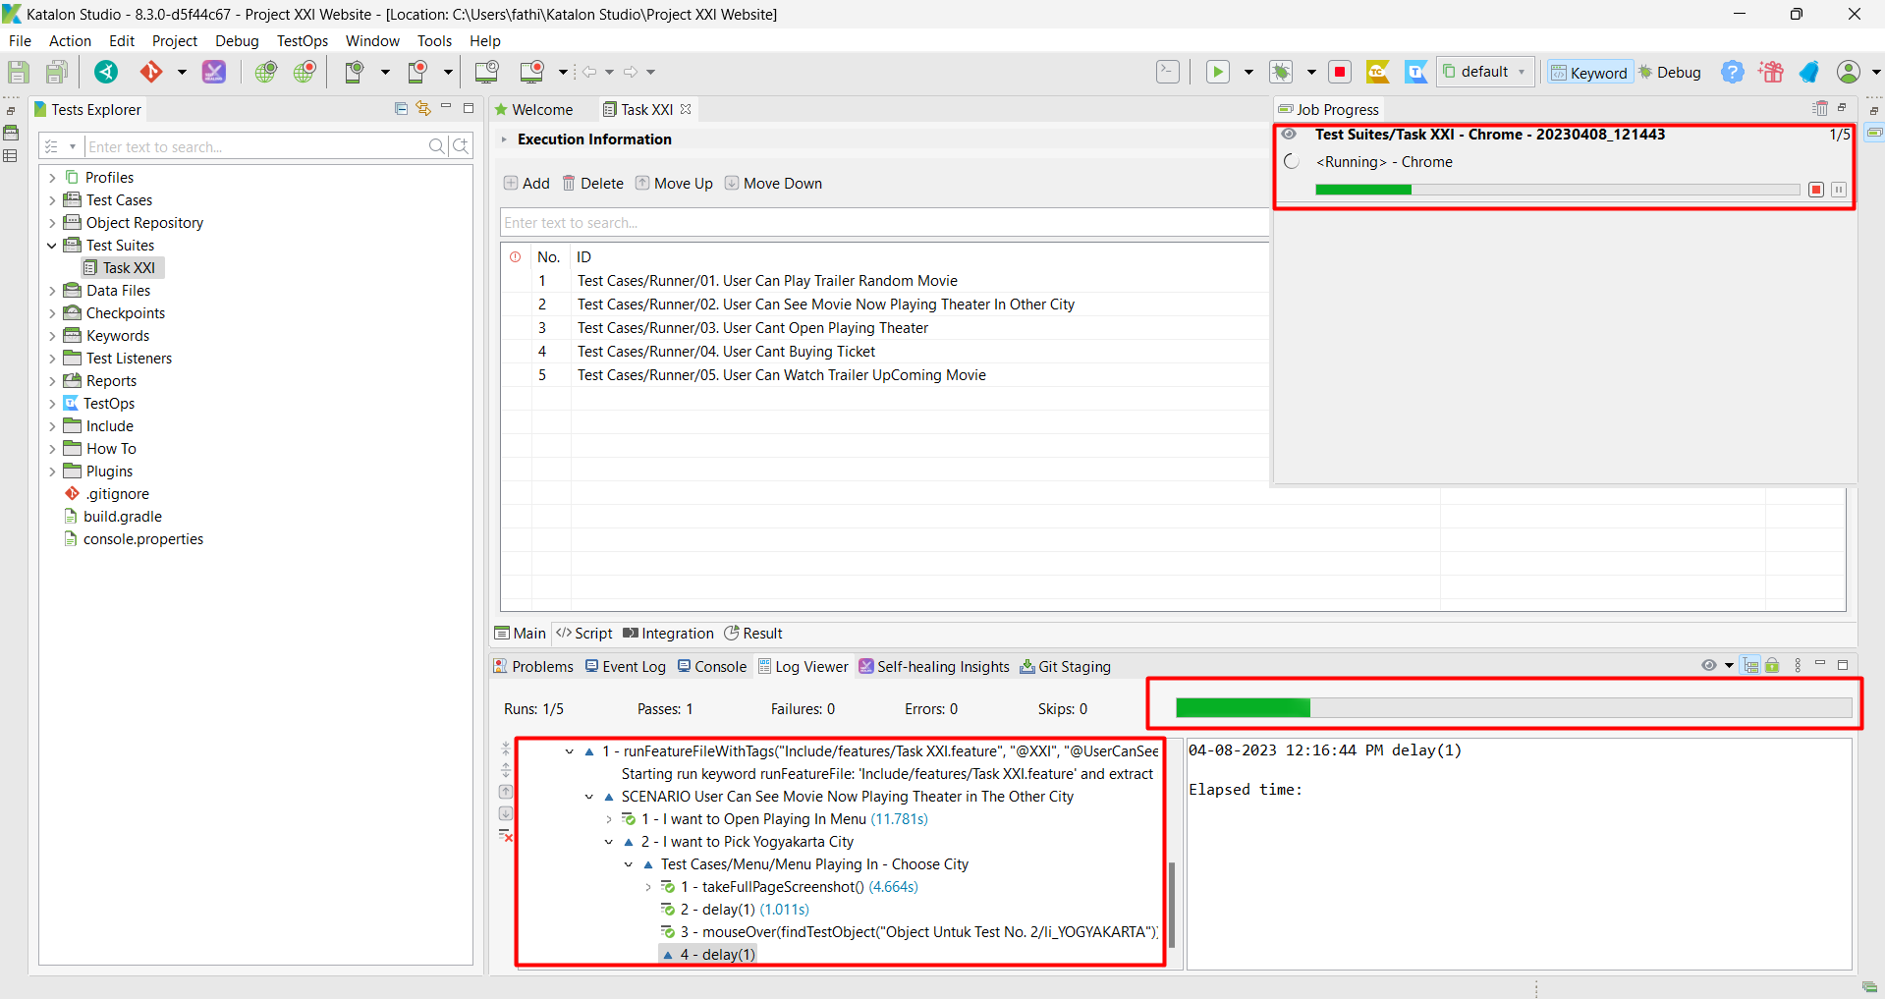

1. You can also see the run script in the browser which opens automatically when you run the script
2. After script automation test done, you will see the green bar is full and the notifications give the information about script automation is “Passed”

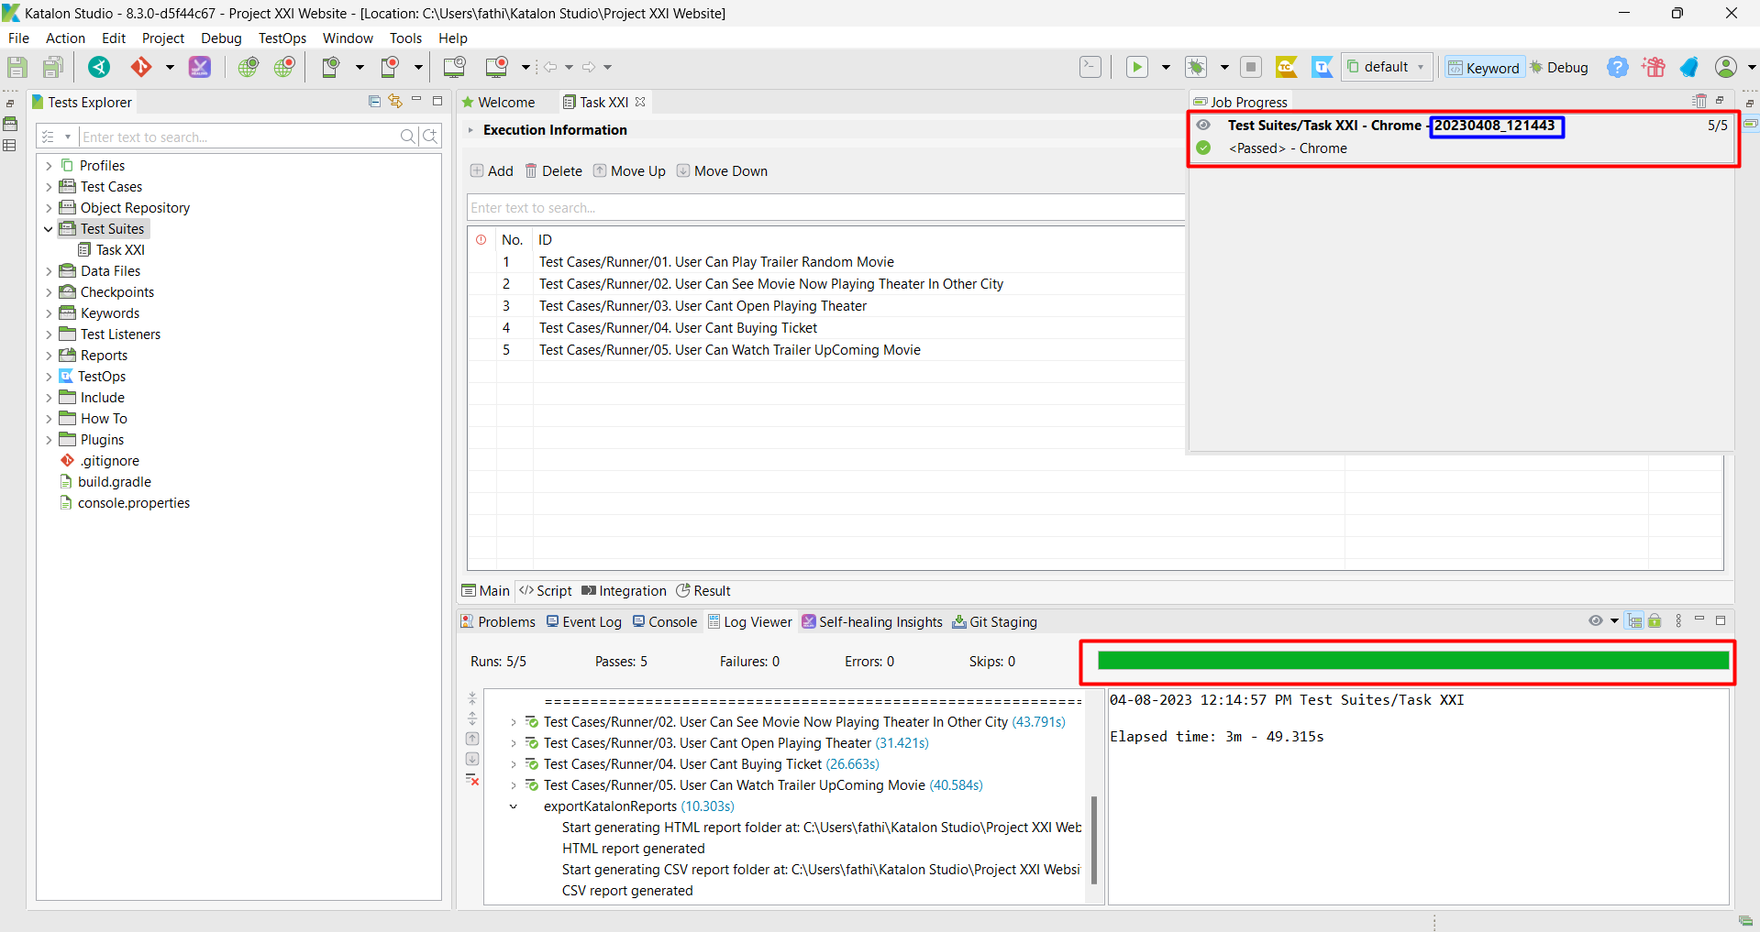

1. And you see the number of report (blue color) in picture above
2. Now, you must Opened the Report Folder and search that based on number of report

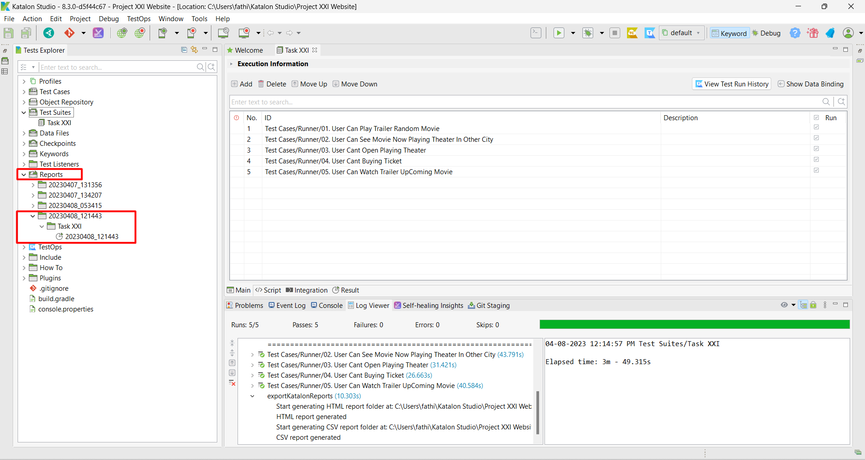

1. After you found that, you can generate the report to HTML or PDF as you want, for example I will generate to HTML. You can Right Click > Export as > HTML > Chose the destination Folder. Or you can opened the “ Open Contain Folder “ and you opened the HTML

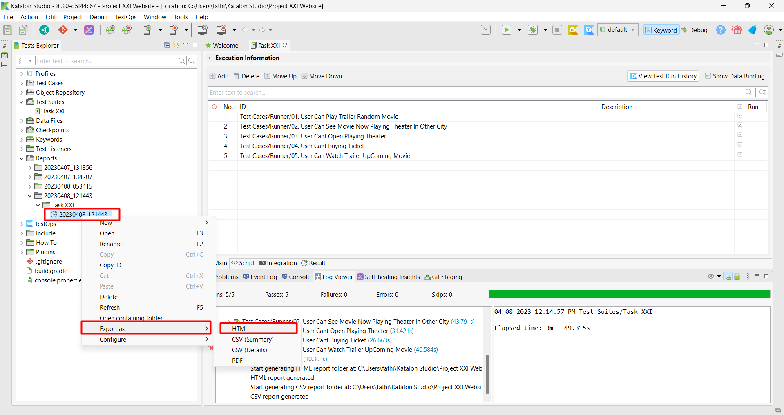

1. Open the HTML file, the file will generate same with the number of report in Katalon Studio

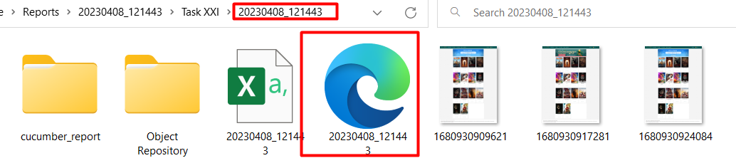

1. You will see the Execution log, and you can analysis the report. If you found error you can trace from the that log.

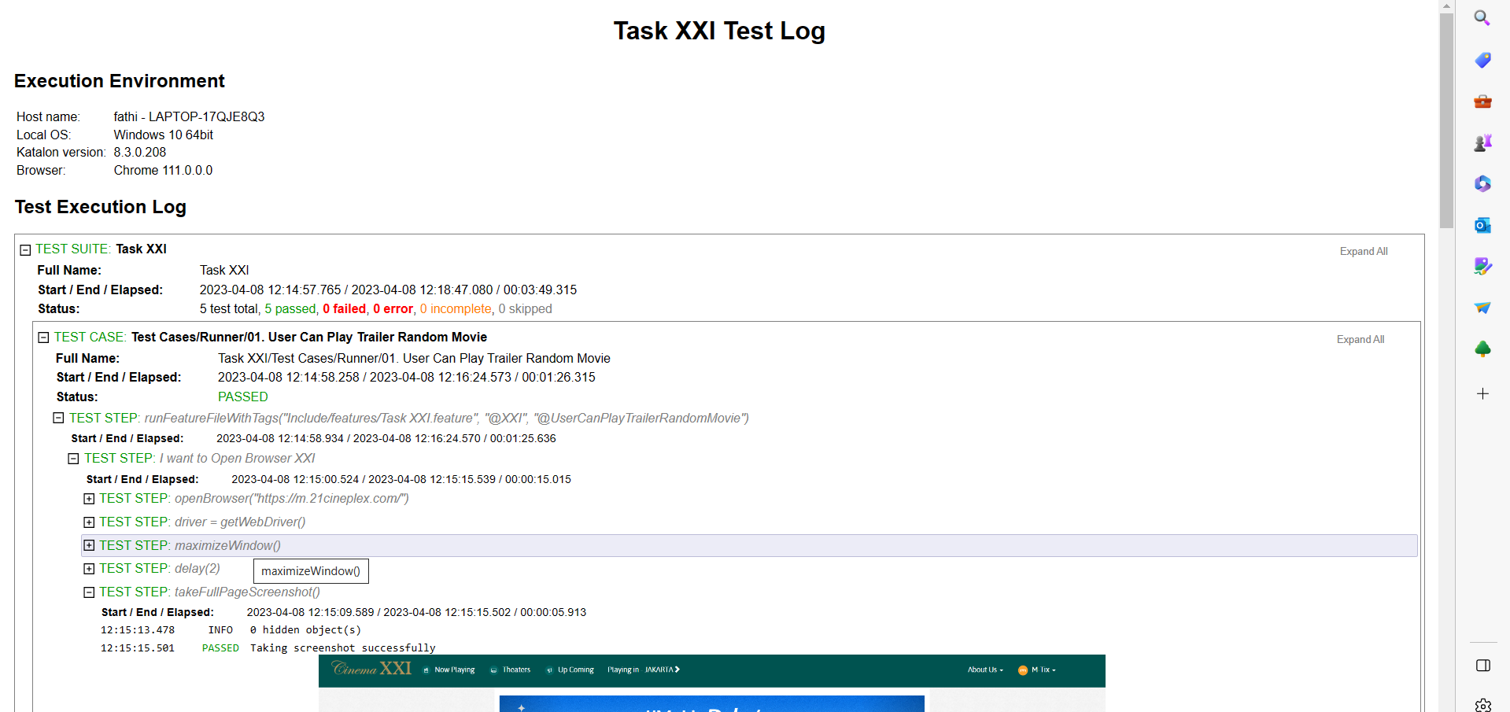

Note :

If you can’t run the Test Suites, you have 2 Option :

Option 1 :

* 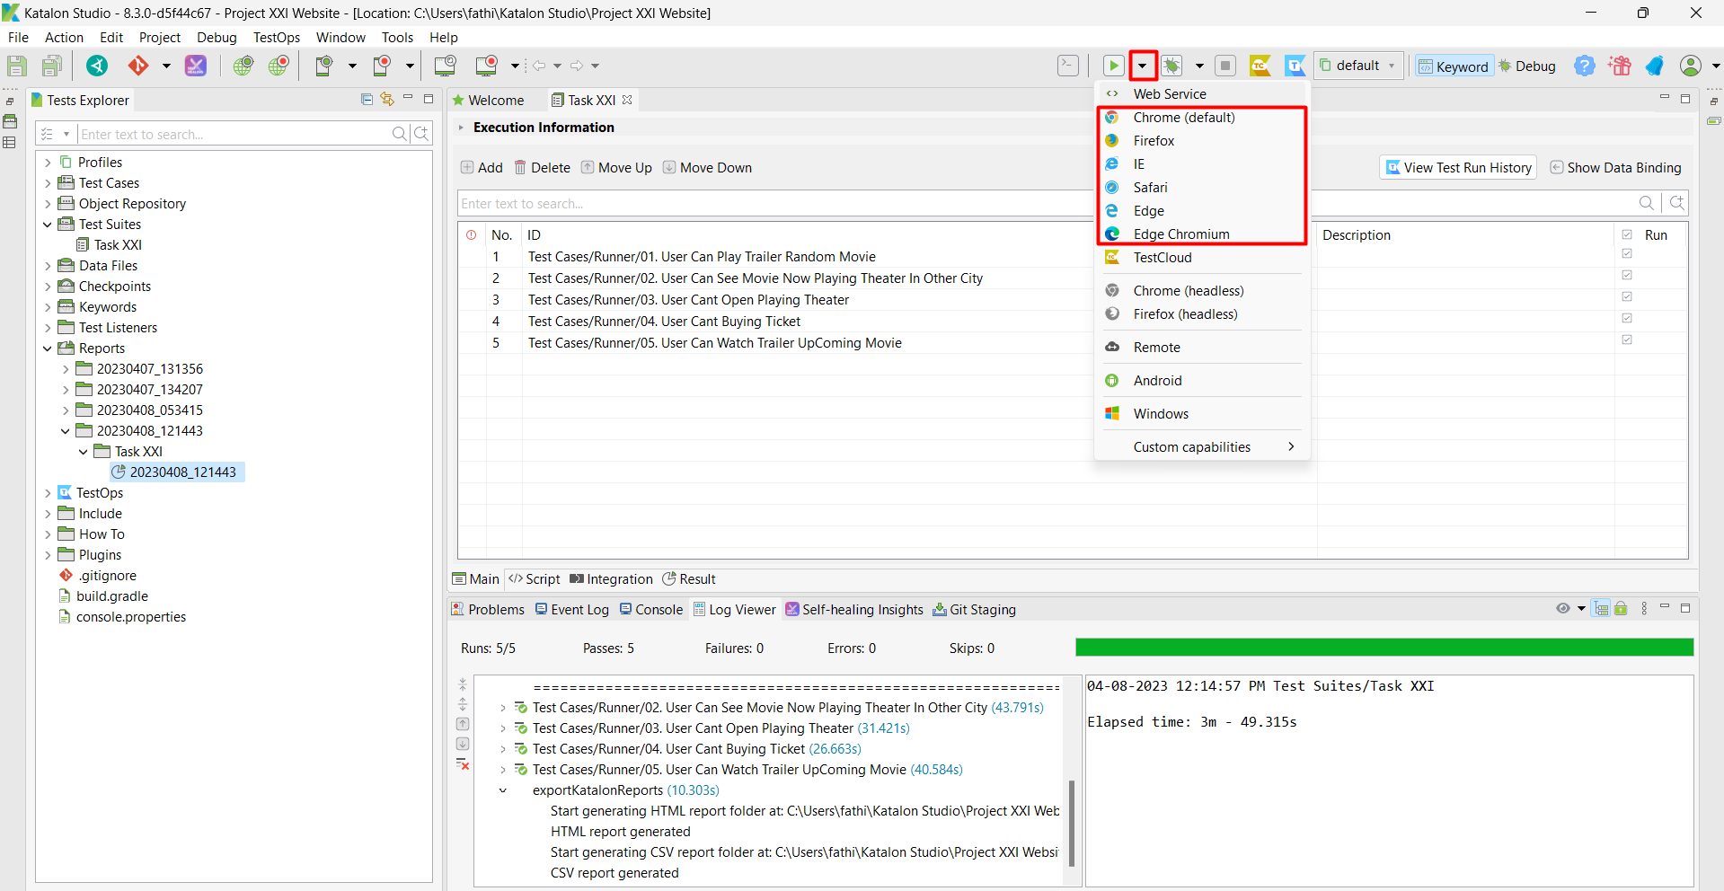Choose Another Web Browser for run The Suites

Option 2 :

* 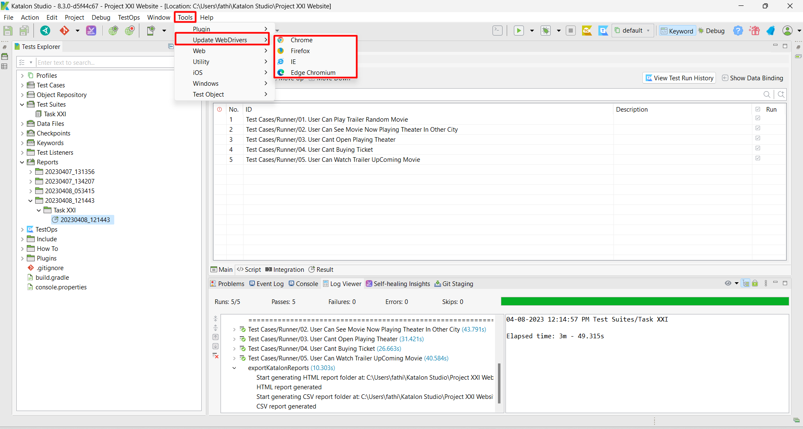Update Web Drivers. Tools > Update WebDrivers > Choose the Browser. And wait until the update process finished

The Proccess :

If you Run the Test Suites, Test suites will trigger the “Runner”, and runner will be run trigger the “Feature/Cucumber”, and it will be trigger “Groovy/Gherkin”, and will triggered the “Test Case”.

So, the flow is : Test Suites > Runner > Feature > Groovy/Gherkin > Test Case

Ps :

* The Runner is in the Test case > Runner folder
* The Feature is in the Includes > Features > … .feature
* The Groovy/Gherkin is in the Includes > Script > Groovy > TaskXXI > …. .groovy